Metjewel Admin User documentation

1. Sign up in localhost:3030, insert Employee name, email, roles and submit.
2. Once accepted, you’ll be receiving an email to share Metjewel database.
3. Click on the link given, it will send you to Mongo DB atlas website.

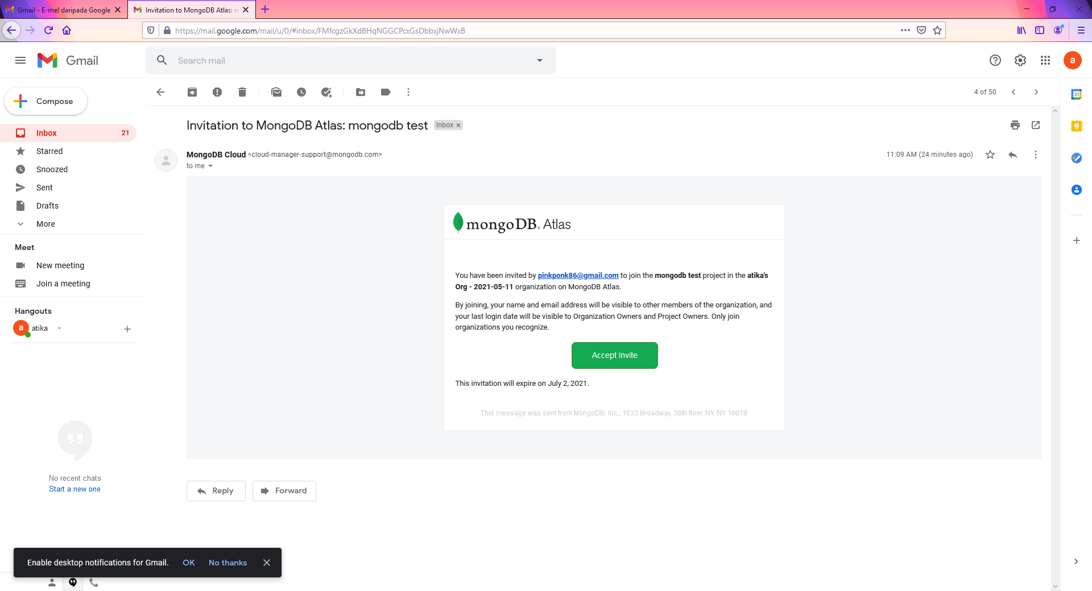

1. Login to your Mongo DB Atlas Account

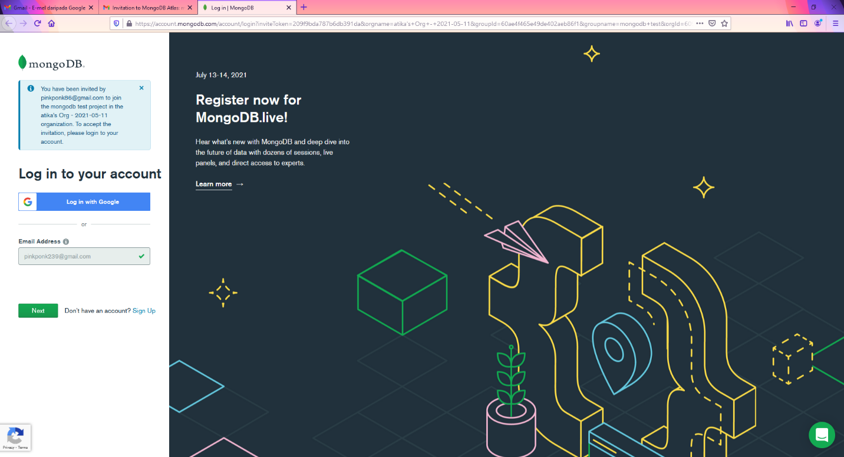

1. Click on the Collection to view the database

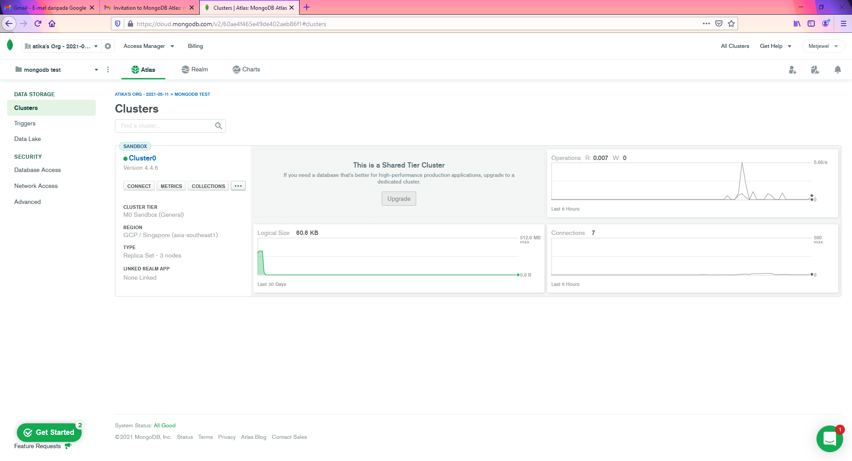

1. Database shown

